# Exercises: JavaServer Faces

Problems for exercises and homework for the [“Java Web Development Basics” course @ SoftUni](https://softuni.bg/trainings/1844/java-web-development-basics-january-2018/internal). Submit your solutions on the **course page** of the **current instance**.

## Employee Register

You have been tasked to create a simple page using JSF, for a big company. The page should support displaying, creating and deleting data about employees. The page should also present aggregated data in the form of sums and averages.

Start by creating the **Employee** class. It should have the following properties:

* **First Name**
* **Last Name**
* **Position**
* **Salary**
* **Age**

### Displaying Employees

Add some employees from the code (in a static collection or just any way you want) and display them like this.

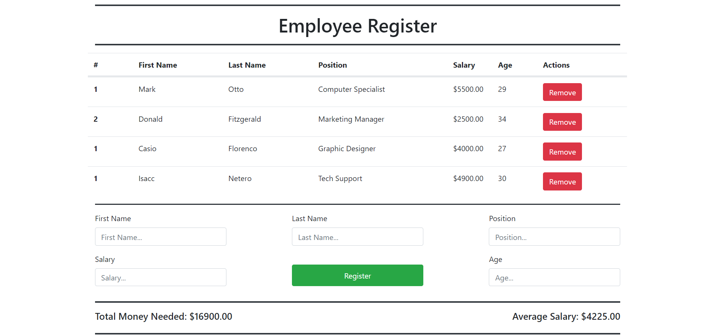

**NOTE**: Use the **given HTML** resources to construct the JSF exactly like the screenshot above.

### Deleting Employees

Implement functionality for **removing** **employees**. By clicking on the [Remove] button, the corresponding employee should be **deleted** .

### Creating Employees

Creating Employees is simple. Implement a form on the page (again, using the given HTML resources), for Employee creation. It should have fields for **First Name**, **Last Name**, **Position**, **Salary** and **Age**.

The **Salary** and **Age** should be **number-type** inputs.

You don’t need an additional page. Everything from this task will be done on this page.

The form should look like this:



**Submitting** the **form** (clicking on the [Register] button) should **initialize** an **Employee object,** with the data from the **input fields**. If there is an **empty field**, **NOTHING** should happen, and **NO** Employee should be added.

### Aggregating Employees

Finally, implement a simple aggregated data about the **Total Salary** needed to pay all **Employees**, and the **Average Employee Salary** given.

This data should depend only on the existent **Employees**. **Deleted Employees** do **not** **figurate** in this data.

It should look like this:



### Expected Result

Now, if you have implemented everything correctly, you should have a fully functional Employee Register Page, which looks like this:

